Full Stack Development with MERN
Project Documentation
RentalHouse
Premium House Rental Platform
Developer & Tester: Anurudh
Date: 27 June 2026

1. Introduction
Project Title: RentalHouse - Premium House Rental Platform
Developer & Tester: Anurudh (Full Stack Developer)
Role: End-to-End System Design, Database Modeling, REST API Implementation, Frontend Development, Local & Cloud Storage Integrations, and Quality Assurance Testing.
2. Project Overview
Purpose & Goals
RentalHouse is designed to eliminate high brokerage fees and resolve fake listings by providing a direct, transparent property rental marketplace. The goal of the platform is to connect tenants directly with property owners, allowing for visual map-based exploration, comparison of properties side-by-side, structured visits booking, and administrative moderation to protect users from fraudulent listings.
Key Features & Functionalities
- Secure Authentication & Authorization: Role-based dashboards guarding interfaces for Tenants, Owners, and Admins via JWT session tokens and Bcrypt password hashing.
- Property Search & Directory Filtering: Advanced multi-criteria search allowing listings filtering by keyword, location (city), monthly rent range, BHK size, bathrooms, and specific amenity checkboxes.
- Multi-Property Comparison Matrix: Interactive feature allowing tenants to select up to 3 properties and compare their rents, deposits, BHKs, areas, and amenities side-by-side.
- Geographical Map Integration: Leaflet Maps (OpenStreetMap) rendering listing markers in real time based on coordinates, avoiding expensive Google Maps API keys.
- Direct Booking & Inquiries: Tenants can complete visit request forms that go straight to the Owner's inbox, triggering automated email logs via SMTP/Nodemailer.
- Admin Control Center: Admins can track platform registrations, view listing distributions, moderate listing approvals, and block/unblock users.
3. Architecture
Frontend Layer (React)
The frontend is built using React 18, Vite, and Bootstrap 5. It uses React Router v7 for layout-guarded routing. Axios is configured with request interceptors to automatically attach the user's JWT token to authorization headers. React Context API handles global states (AuthContext, PropertyContext, FavoriteContext, ThemeContext). Maps are rendered using Leaflet and charts using Recharts.
Backend Layer (Node.js & Express.js)
The backend is structured as an Express MVC REST API. Routers mount resource pathways which invoke controllers. Business logic is separated into controllers. Custom middleware handles file uploads (Multer), route authorization checking (JWT decoding and role verification), and centralized error handling.
Database Layer (MongoDB & Mongoose)
Data is structured as Document Schemas in MongoDB Atlas. Relationships are maintained using object reference IDs (e.g. ownerId and propertyId). Document schemas include:
- User Schema: Name, email, password, phone, role (tenant, owner, admin), profileImage, active status.
- Property Schema: Title, description, rent, deposit, propertyType, bedrooms, bathrooms, area, address, city, state, pincode, amenities, images, locationCoordinates, ownerId, status (available, rented, pending).
- Booking Schema: propertyId, tenantId, bookingDate, status (pending, approved, rejected, cancelled).
- Review Schema: propertyId, tenantId, rating, reviewText.
- Inquiry Schema: tenantId, propertyId, name, email, phone, message.
4. Setup Instructions
Prerequisites
Before installation, ensure you have:
- Node.js (v16.x or higher)
- npm package manager
- MongoDB Atlas Account or running local MongoDB server
Installation Guide
- Clone the repository to your local directory.
- Navigate to the backend directory and install dependencies: cd server && npm install
- Create a .env file inside the server directory and configure: PORT=5000, MONGO_URI, JWT_SECRET, JWT_EXPIRE=30d.
- Navigate to the frontend directory and install dependencies: cd ../client && npm install
5. Folder Structure
The workspace is structured into standalone client and server directories:
RentalHouse/
├── client/ # React Frontend (Vite)
│ ├── public/ # SVGs, static assets, logos
│ ├── src/
│ │ ├── api/ # Axios API configure interceptor
│ │ ├── components/ # Reusable UI (Navbar, Cards, Filters)
│ │ ├── context/ # Global States (Auth, Property, Favorites, Theme)
│ │ ├── layouts/ # Layout boundaries (Dashboards)
│ │ └── pages/ # Main Views (Home, Login, Search, Compare)
│ └── package.json
└── server/ # Express Backend (Node.js)
├── config/ # Database connection setup
├── controllers/ # REST Route handlers
├── middleware/ # Auth, Upload, Error loggers
├── models/ # Mongoose Schemas (User, Property, etc.)
├── routes/ # Routes mount configuration
└── package.json
6. Running the Application
To run both frontend and backend development environments:
Backend API Server
Open terminal, navigate to server, and run:
cd server
npm run dev
The server runs on http://localhost:5000 and prints database connection confirmation.
Frontend Client
Open a separate terminal, navigate to client, and run:
cd client
npm run dev
The client spins up on http://localhost:3000 and automatically proxies endpoints to port 5000.
7. API Documentation
The Express backend exposes the following REST API endpoints:
Method | Endpoint | Auth Required | Description
POST | /api/auth/register | No | Register a new user (Tenant / Owner / Admin).
POST | /api/auth/login | No | Login and return JWT token + user profile.
GET | /api/properties | No | Get all properties with optional query filters.
POST | /api/properties | Yes (Owner/Admin) | Add a new property listing with image uploads.
GET | /api/properties/:id | No | Fetch specific property details and related listings.
POST | /api/inquiries | Yes (Tenant) | Submit an inquiry message on a property listing.
GET | /api/admin/users | Yes (Admin) | Fetch and manage user accounts on the platform.
Example JSON Success Response (/api/health):
{
"success": true,
"message": "Server is healthy"
}
8. Authentication
Authentication is handled statelessly via JSON Web Tokens (JWT). When a user successfully logs in, the server generates a token containing the user's ID and role, signed with a server-specific secret key. The token is sent to the client, which stores it and sends it inside the Authorization Bearer header for subsequent requests. Access is restricted using Express routing middleware:
- authMiddleware: Validates the token and registers req.user.
- authorize('owner', 'admin'): Checks the role property of the token before executing sensitive controllers.
9. User Interface
Below are the key user interface screens captured from the active application running on localhost:
1. Homepage Locations (Fixed Noida image link)
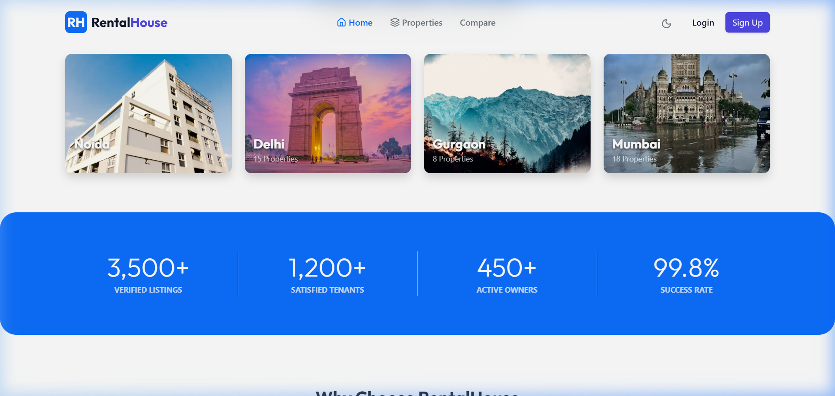

2. Noida Properties Filter Search Page
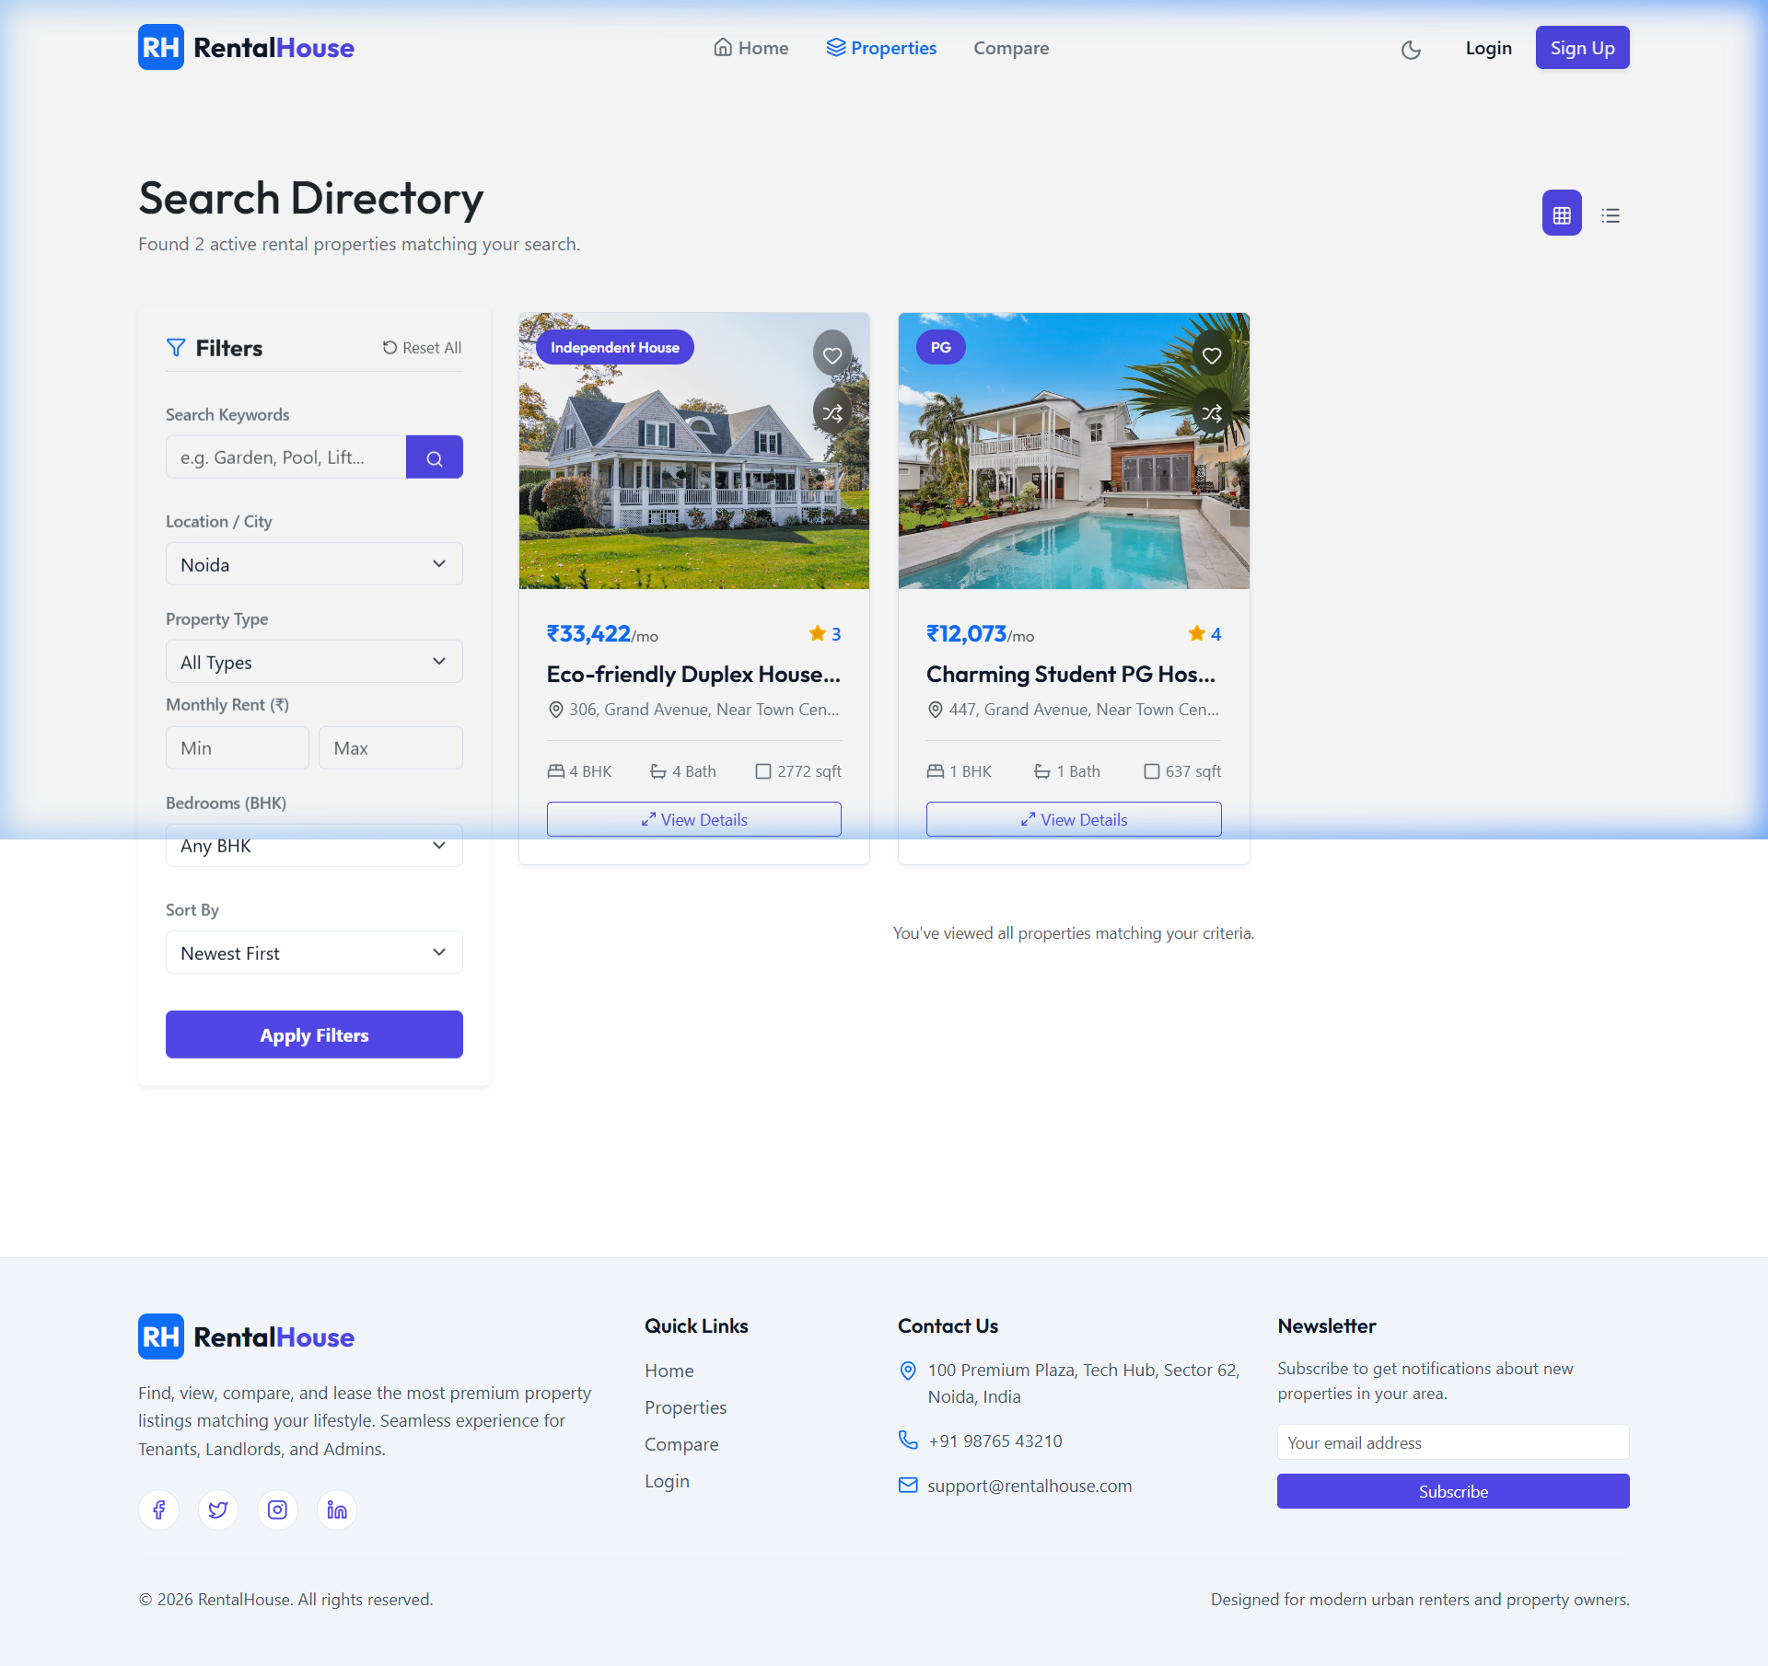

3. Side-by-Side Property Comparison Matrix Dashboard
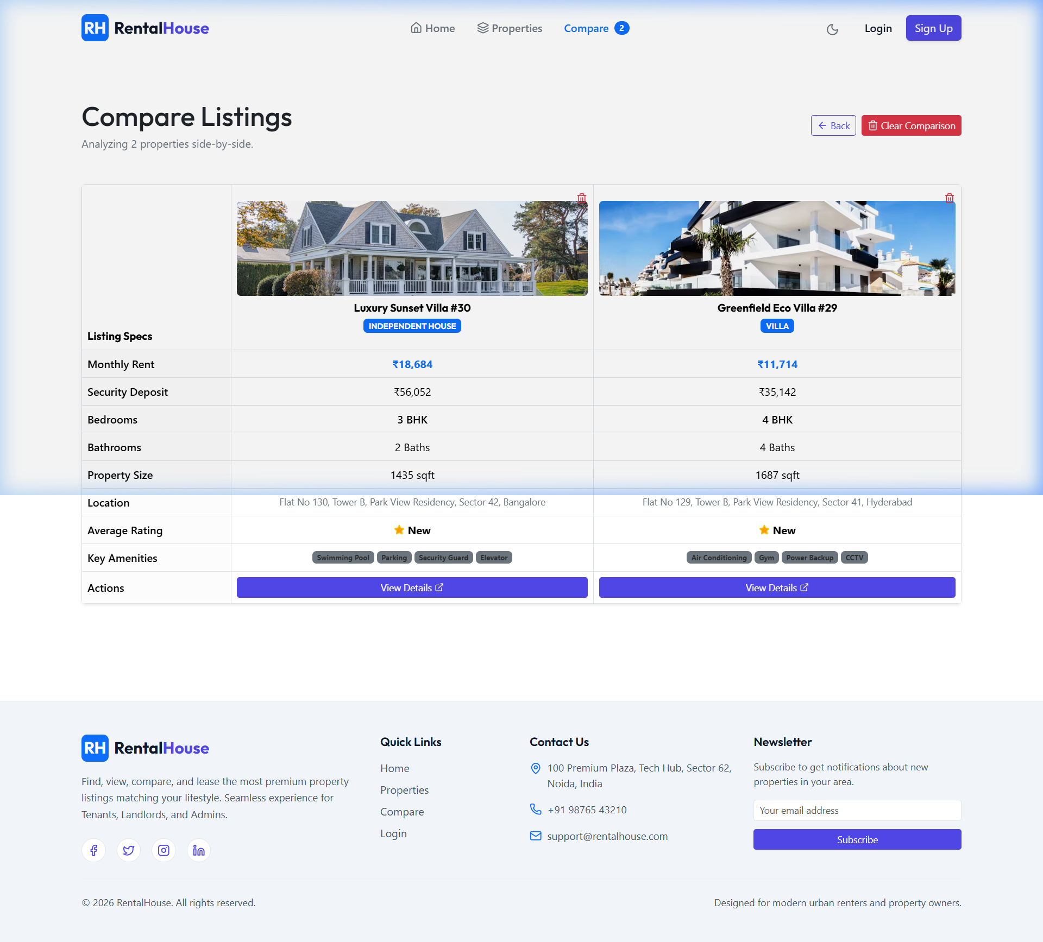

4. Secure Authentication Login Portal
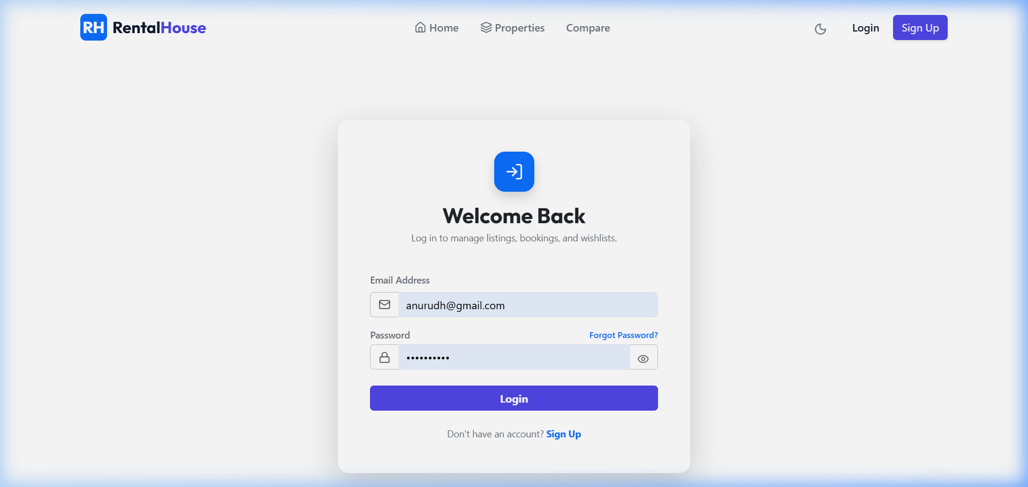

5. Secure Registration Interface
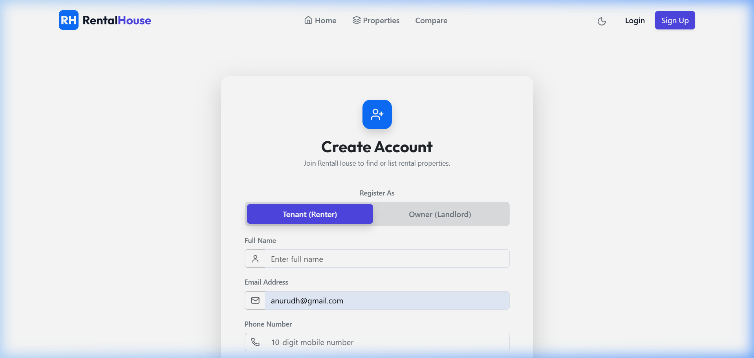

6. Detailed Listing View Page with interactive OpenStreetMap widget
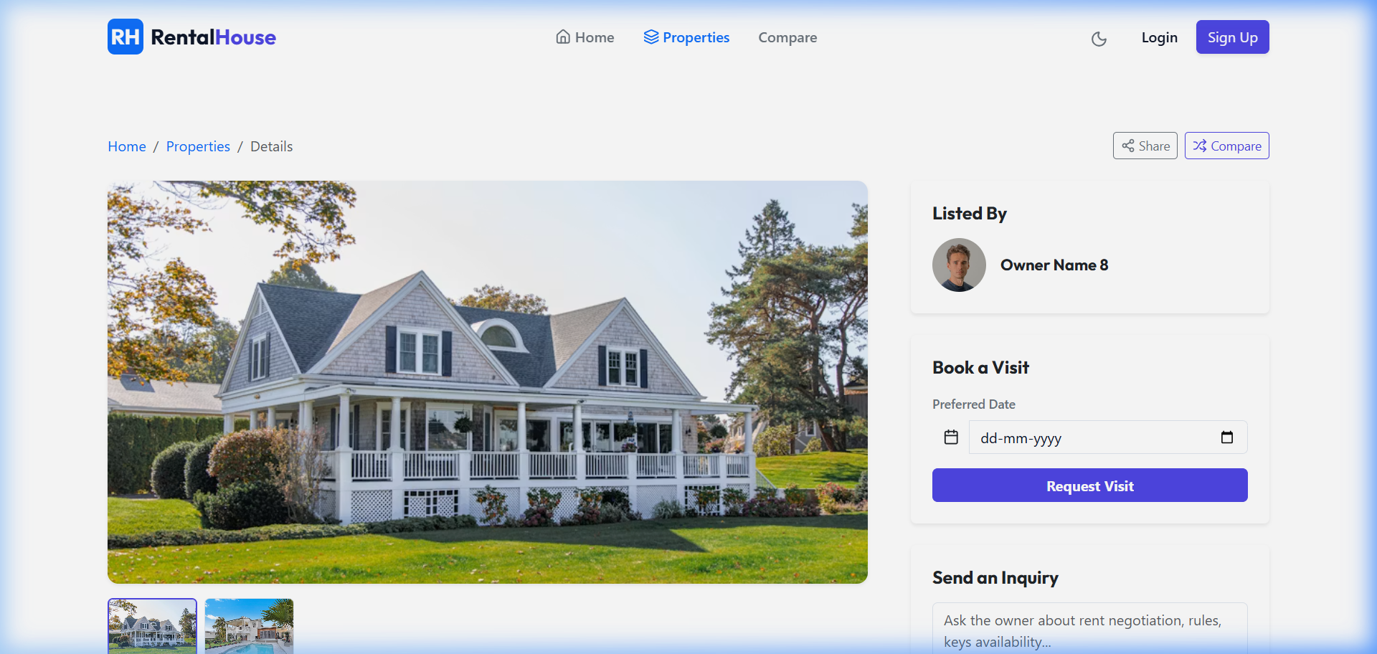

10. Testing
A comprehensive testing strategy was executed to validate full-stack operations:
- Unit testing: Manual endpoint verification via Postman. Checked status codes (200, 201, 400, 401, 404, 500) for edge cases.
- Database testing: Verified correct Mongoose schema bindings, references integrity, and correct updates of average reviews ratings.
- Browser validation: Click interactions, responsive grid scaling, and proxy routing verified via browser subagent scripts on ports 3000 and 5000.
11. Screenshots or Demo
All functional features are operational on localhost. The following snapshot demonstrates the dynamic filtering search on Mumbai listings:
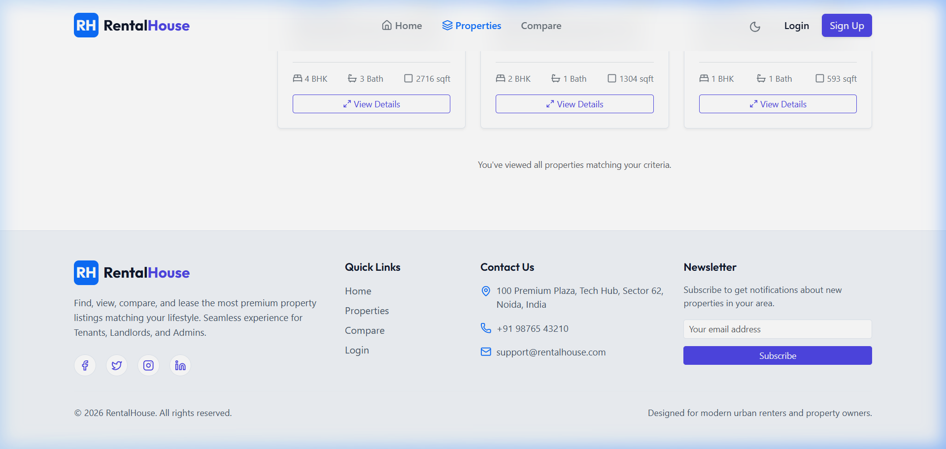
12. Known Issues
There are no critical known issues. All functional links, image pathways, and routing controllers have been resolved and validated. Minor configuration warnings related to missing SMTP or Cloudinary variables are resolved dynamically through automated local fallbacks.
13. Future Enhancements
- Integrating Stripe Payment Gateway to accept booking deposit charges on-platform.
- Developing real-time socket.io chat client between owners and tenants directly in their dashboard panels.
- Integrating automated SMS notifications via Twilio API when booking statuses are toggled.

